Cloud Computing
In the simplest term, Cloud Computing is storing and accessing data and programs over the internet
It is the delivery of computing services (Servers, Storage, Databases, Networking, S/W) over the internet.
On-Demand (Anytime you can create, once do not need to remove it ) and Automated provisioning of computer resources. Ex. Computing, Networking & Storage.
“Pay-Per-Use” or “Pay-as-you-go”, It will charge for the time when using the software.
This server has to be accessed over the internet by using a web-based tool for personal or business use.
Cloud Computing = Virtualization + Internet/Intranet

Benefits of Cloud Computing:
  - Better Scalability (able to be changed in size or scale)
  - Improved Security

Cloud Modules (Cloud Deployment Models)

There are three types of clouds − Hybrid, Public, and Private

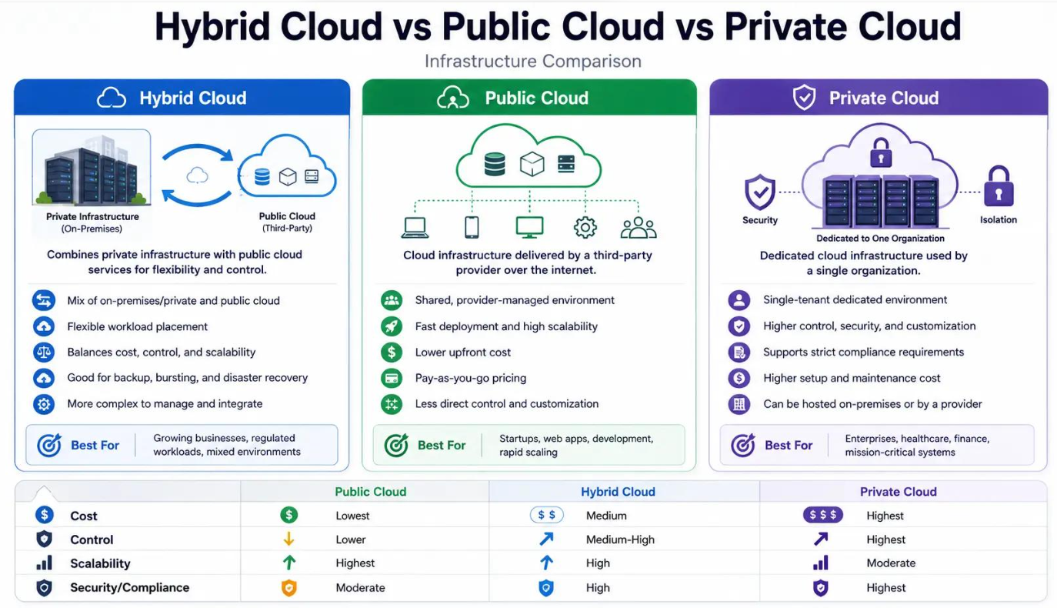

Public Cloud
It is a cloud environment where the infrastructure is owned and operated by a cloud service provider, and organizations consume resources over the internet.

The organization does not own the physical data center infrastructure.

Architecture
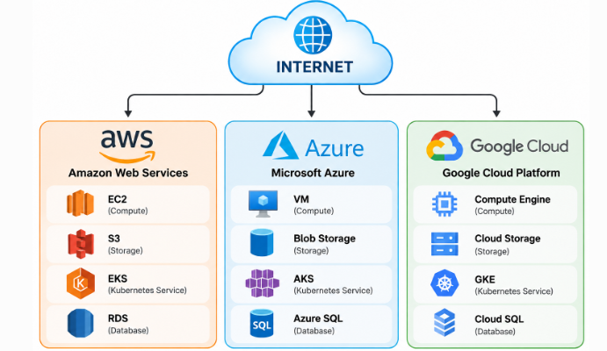

Example – Banking
Suppose a bank develops a mobile banking application.

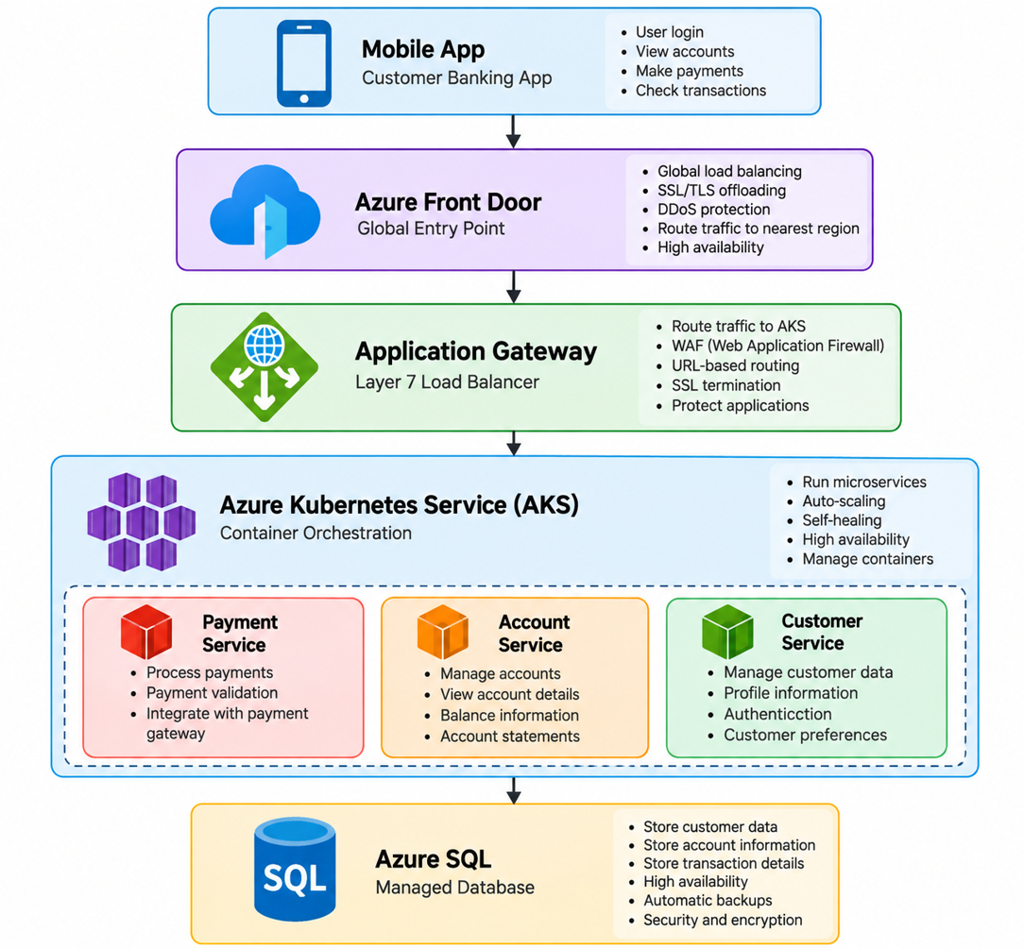

 | DDoS Protection | WAF
Full form | Distributed Denial-of-Service Protection | Web Application Firewall
Main purpose | Protect availability from traffic floods | Protect web apps from malicious requests
Focus | Network/transport and volumetric attacks, plus certain protocol attacks | HTTP/HTTPS application-layer traffic
Example | Millions of requests/packets flooding an endpoint | SQL injection / XSS
Typical Azure services | Azure DDoS Protection | Application Gateway WAF, Front Door WAF

Advantages
- Lower upfront infrastructure cost
- Fast provisioning
- Highly scalable
- Global availability
- Pay-as-you-go
- Managed services

Private Cloud
It is a cloud environment dedicated to one organization.

The infrastructure hosted,
- On the organization's premises
- In a dedicated data centre
- By a third-party provider
In this type of cloud, major control is over the infrastructure so security-related issues are minimized.

Unlike public cloud, the infrastructure is not shared as a general cloud environment with other organizations.

Architecture

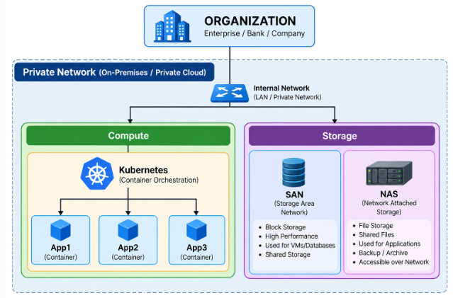

Example – Bank
A large bank may maintain its own private cloud for highly controlled workloads.

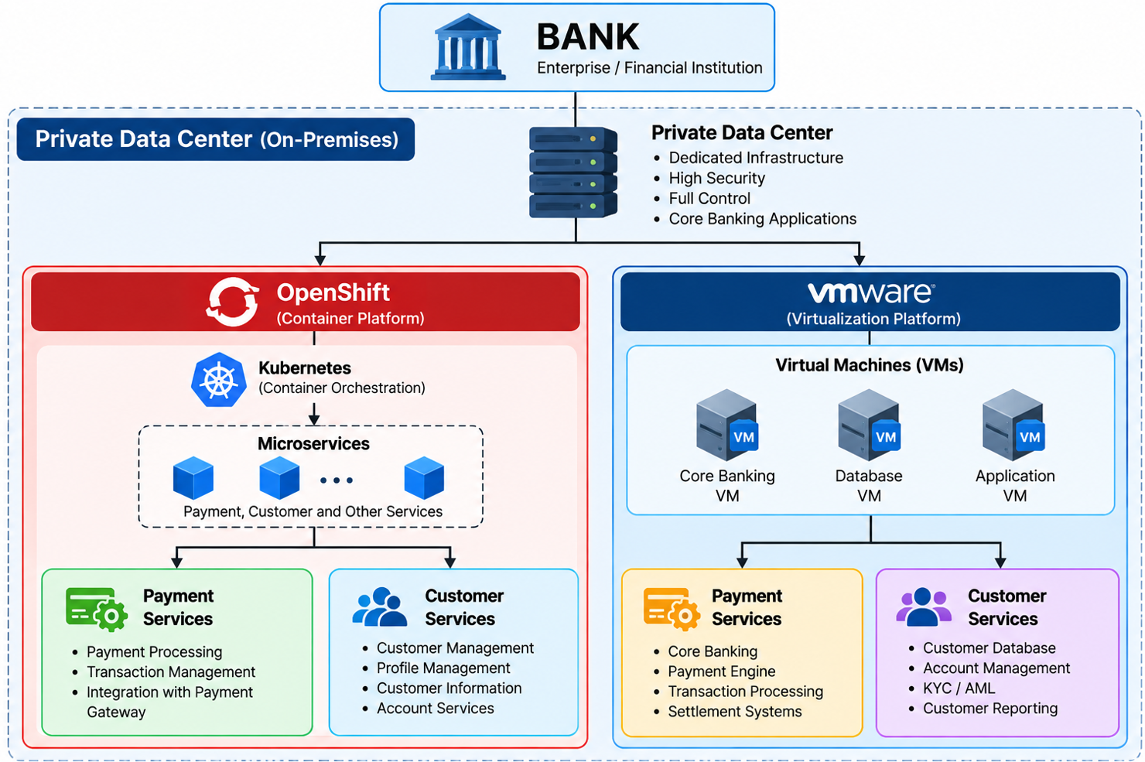

Advantages
- Greater infrastructure control
- Dedicated environment
- Custom security policies
- Strong governance
- Can support strict compliance requirements
- Custom network architecture

Challenges
- Higher infrastructure cost
- Requires skilled IT teams
- Hardware lifecycle management
- Scaling can require additional infrastructure

Hybrid Cloud

A hybrid cloud is a combination of both private and public clouds, allowing workloads and data to operate across both environments.

Architecture

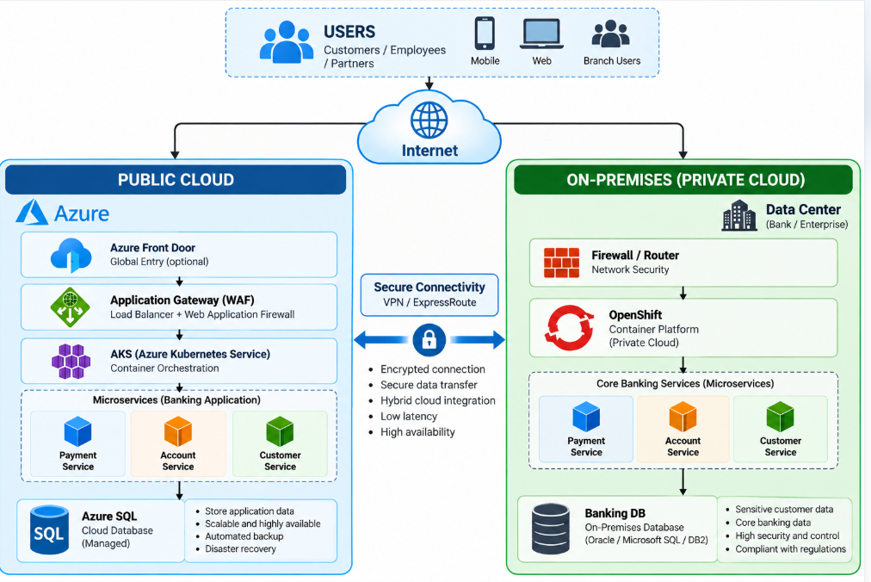

Banking Example, imagine a bank has:

Private Cloud:
- Customer master data
- Core banking
- Payment processing
- Highly sensitive workloads

Public Cloud:
- Mobile application
- Analytics
- AI/ML
- Customer notifications
- Development/testing

Cloud Services (Cloud Service Model)

Cloud services are infrastructure, platforms, or software that are hosted by third-party providers and made available to users through the Internet.

There are three types of service models in the cloud − IaaS, PaaS, and SaaS.

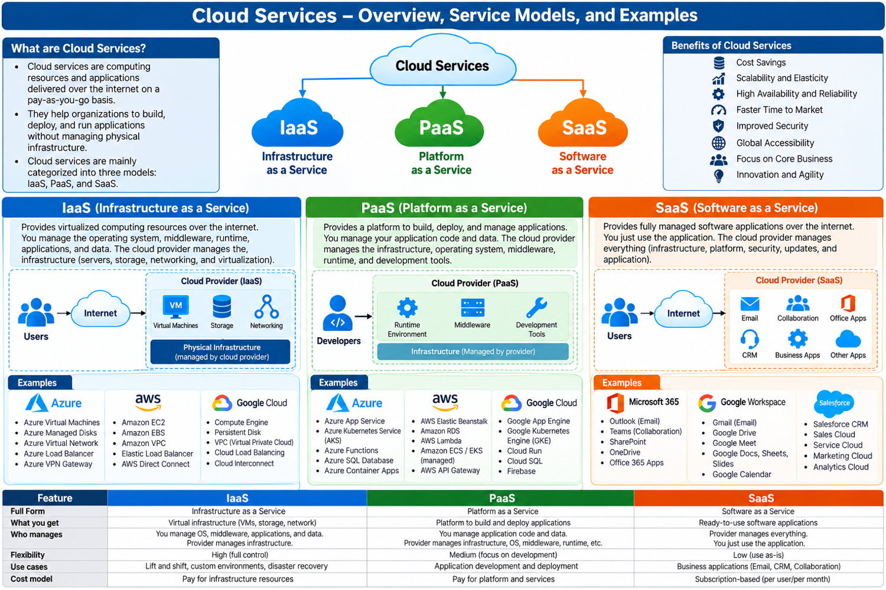

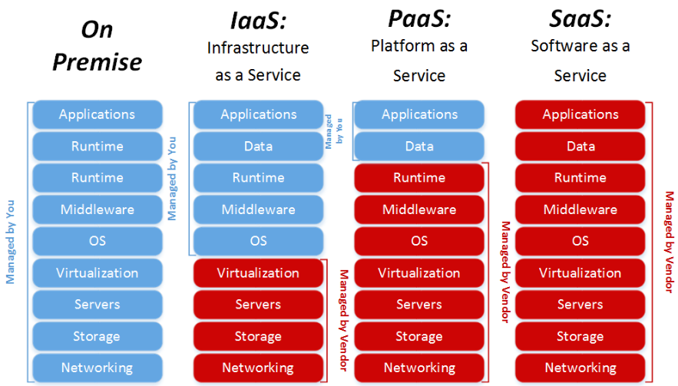

Cost Effective Solution Cloud computing
CAPEX (Capital Expenditure Expenses), is where you pay for something upfront (of a payment in advance).

OPEX (Operational Expenditure Expenses), the “Pay-as-you-go” model, you pay for services as you use them.

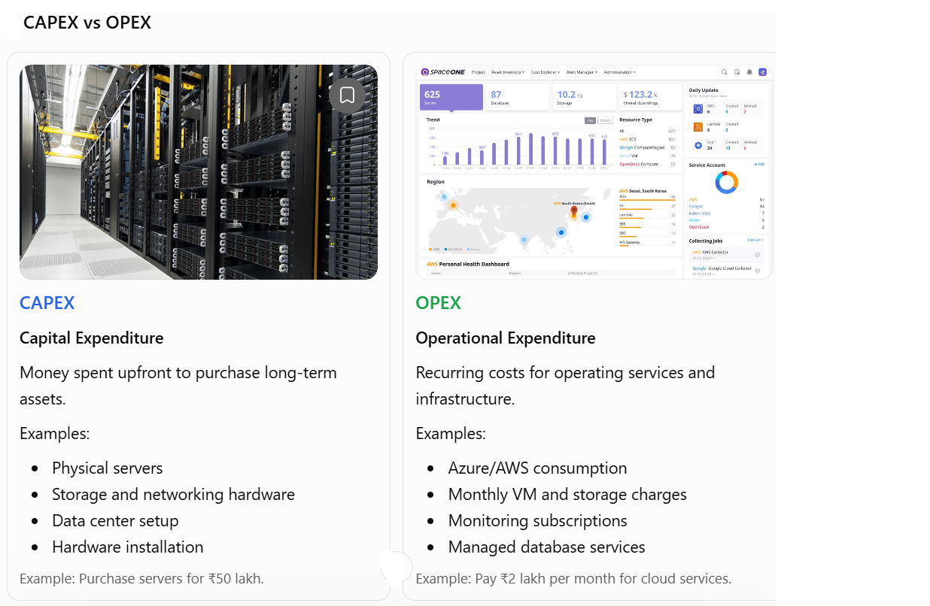

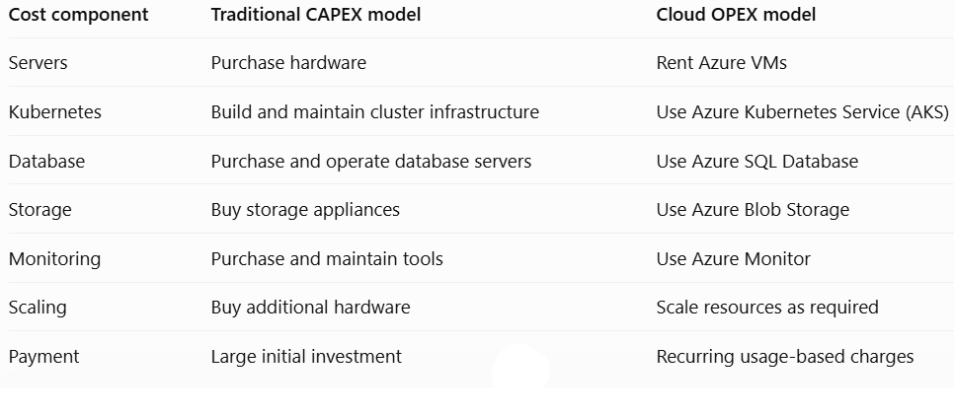

How IaaS, PaaS and SaaS relate to OPEX
Cloud model | Example services | Typical cost approach
IaaS | Azure Virtual Machines, AWS EC2 | Pay for compute, storage, networking and related services
PaaS | Azure App Service, Azure SQL Database | Pay for managed platform capacity and usage
SaaS | Microsoft 365, Salesforce | Subscription or usage-based pricing
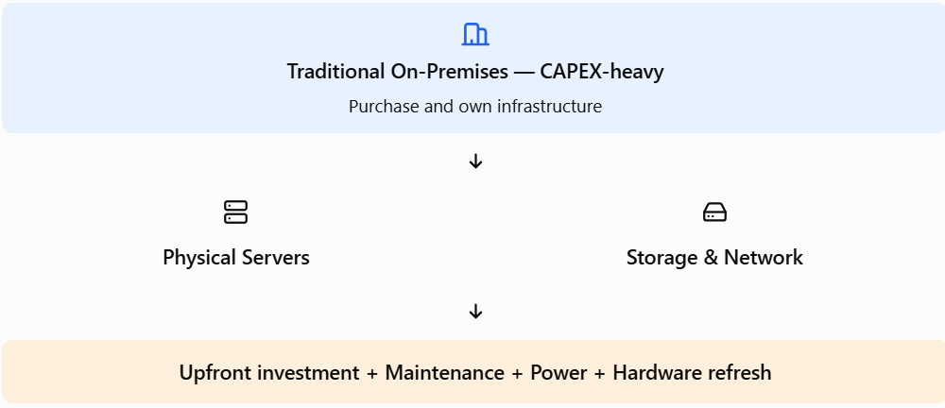

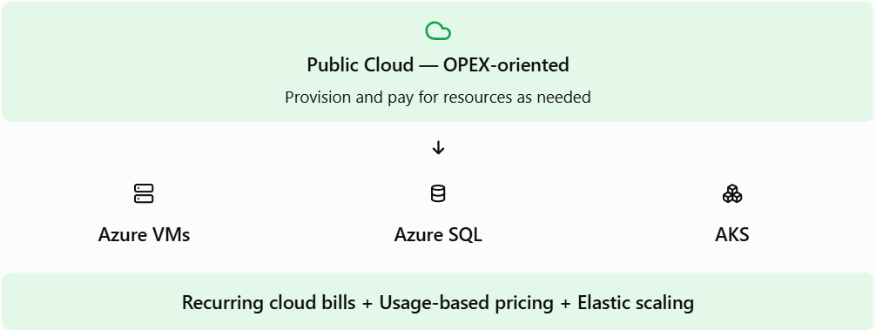

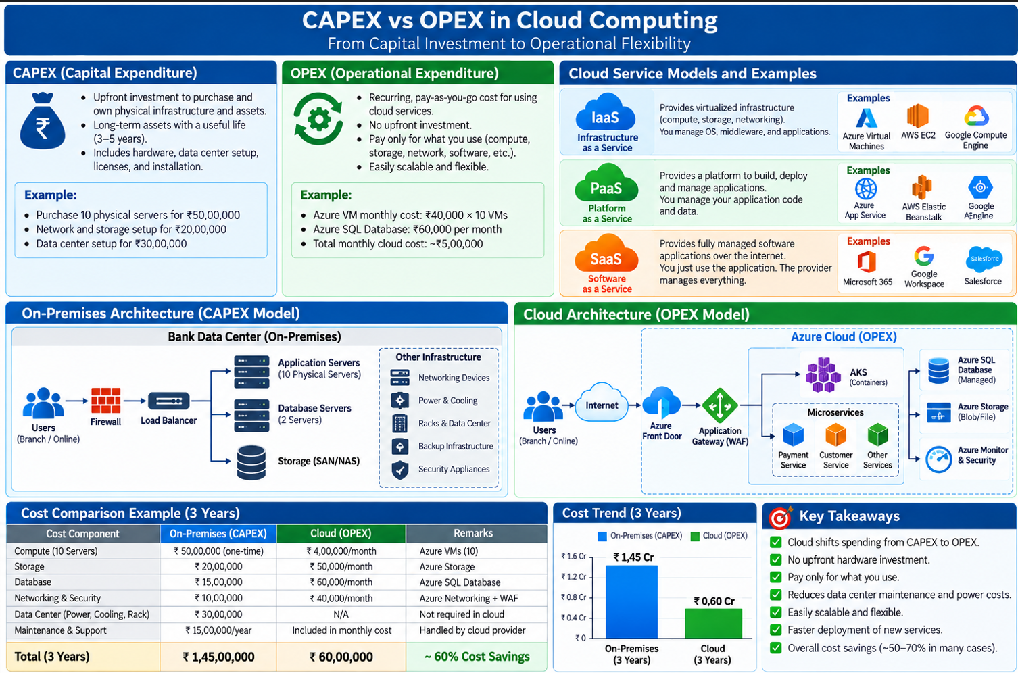

Cloud does not automatically mean cheaper.
Cloud cost optimization requires right-sizing, shutting down idle resources, selecting suitable pricing plans, using autoscaling, and monitoring consumption.
Key takeaway: CAPEX means investing in infrastructure upfront;
OPEX means paying ongoing operational costs.
Public cloud often shifts spending toward OPEX, while private and hybrid environments may involve both CAPEX and OPEX.

